Assignment 1
Name: Tiwari Adarsh Rameshchandra
Roll. No: 2415001684
————————————————————————————————————————
Question 1: Frontend, Backend, and Full-Stack Development
Think of web development like building a community health clinic. To make it function well, different people focus on different areas:
• Frontend Development (The Welcome Area): This is everything a visitor sees and interacts with. Just like the clinic's reception desk, comfortable chairs, and helpful signs, the frontend consists of the buttons, text, colors, and layouts on a screen. It makes sure the system is beautiful, clear, and easy for everyone to navigate.
• Backend Development (The Support Office): This is the powerhouse that works quietly behind the scenes. Like the clinic's pharmacy and filing cabinets, the backend handles the rules, data processing, and security. It safely stores medical records and coordinates inventory so that when a patient requests medicine, the system delivers it correctly.
• Full-Stack Development (The All-Rounder): This describes building both the frontend and the backend. A full-stack developer is like a versatile community organizer who can sit at the front desk to welcome people and also head into the back office to manage the database, ensuring the entire system flows together harmoniously.
Question 2: The Client-Server Model (Simple Visual Flow)
The client-server model is a simple dialogue built on requests and helpful responses. The client asks for assistance, and the server works to provide it.
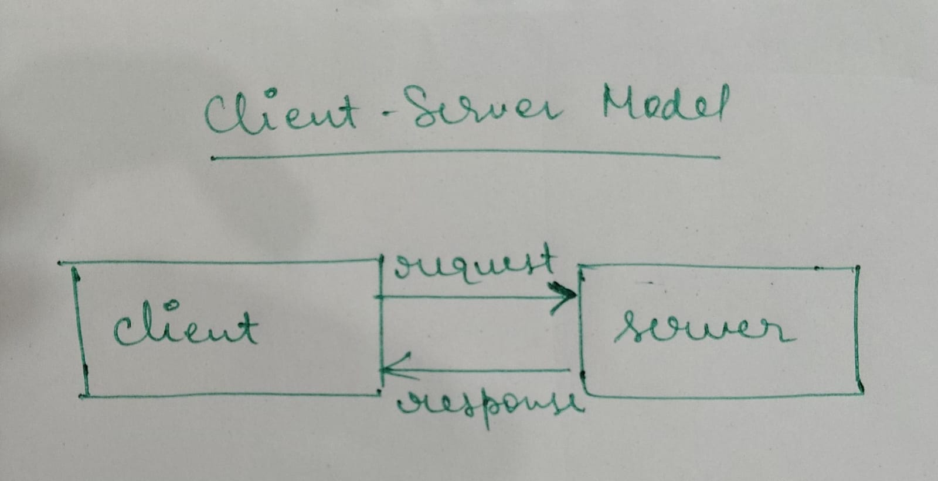
Question 3: How a Browser Requests and Displays a Web Page
When you type a website address and hit enter, a four-step journey takes place:
1. Finding the Address (DNS Lookup): Computers use numbers (IP addresses) like telephone numbers. Your browser looks up the website name in a digital address book called the Domain Name System (DNS) to find exactly where the server is located.
2. Asking Politely (HTTP Request): The browser knocks on the server's door and sends a formal message asking, "Could you please share your homepage files?"
3. Sending the Package (HTTP Response): If everything is okay, the server answers with a friendly approval code and sends the website files broken down into tiny packages called packets over the internet.
4. Assembling the Screen (Browser Rendering): Your browser receives these puzzle pieces (HTML, CSS, and JavaScript files) and carefully assembles them into the interactive page you see on your screen.
Question 4: Essential Tools for a Web Development Workbench
To start building, we setup a welcoming digital workbench with four core tools:
• Code Editor (e.g., VS Code): Our digital notebook. It highlights our text in bright colors, catches typos, and helps us write structured, clean files easily.
• Web Browser (e.g., Chrome, Firefox): Our viewing window. It acts as the interactive playground where we test our designs and see how our code behaves in real life.
• Version Control (Git): Our safety net. It records our project history like a diary, allowing us to step back in time if we make a mistake and collaborate safely with teammates.
• Package Manager (e.g., npm): Our community library. It lets us safely download pre-written, open-source code blocks shared by other generous developers to save time and effort.
Question 5: What is a Web Server?
A web server is a specialized, always-on computer that stores a website's files and delivers them to anyone across the world who asks for them. It is like an open public library waiting to hand out books. Common examples include:
• Nginx: A super-fast, light, and modern server great at guiding massive amounts of traffic smoothly.
• Apache: A trusted, classic server that has powered a huge portion of the internet for decades.
• Node.js: A runtime tool that allows developers to write server programs using simple JavaScript, keeping the whole project unified.
Question 6: Key Team Roles in a Web Project
Web development is a team effort. Here is how three crucial roles collaborate:
• Frontend Developer: The Advocate for the User. They focus on making the visual screens clear, highly accessible, and beautiful so that anyone—regardless of their device or ability—can find what they need easily.
• Backend Developer: The System Architect. They write the quiet, powerful behind-the-scenes math and rules that handle secure logins, payments, and data routing smoothly.
• Database Administrator (DBA): The Guardian of Information. They organize and protect vital data (like medical records, community registrations, or textbooks) so it stays clean, safe, and quickly accessible whenever needed.
Question 7: Setting Up VS Code for HTML, CSS, and JS
Setting up your editor is easy. Open VS Code, go to the Extensions tab, and search for these beginner-friendly helpers:
1. Live Server: Launches a local preview of your website that refreshes automatically as you edit. No manual refreshing needed!
2. Prettier: Polishes and aligns your code automatically every time you save, keeping your work clean and legible.
3. HTML CSS Support: Suggests styling shortcuts and auto-completes names as you type, preventing spelling errors.
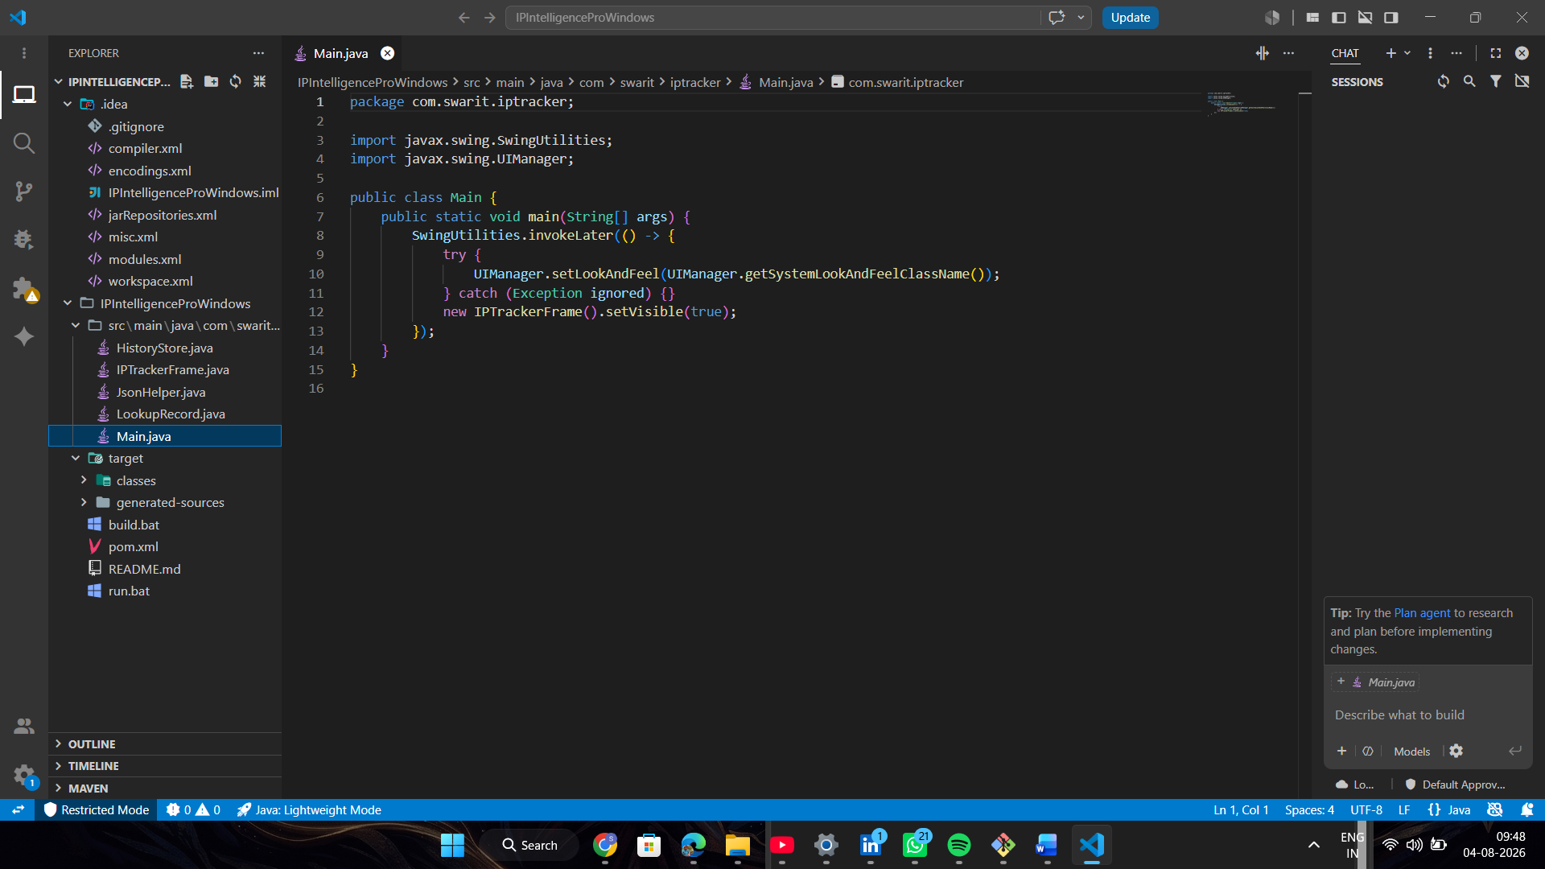

Question 8: Static vs. Dynamic Websites
Websites generally fall into two categories depending on how they serve information:
Feature | Static Website (The Notice Board) | Dynamic Website (The Live Assistant)
What it is | Displays the same, pre-written content to every single visitor. | Creates fresh, customized content in real time based on who is asking.
Real-World Example | A simple local flyer or a restaurant's static dinner menu. | An interactive clinic booking portal or a personalized study dashboard.

Question 9: Browsers and Their Rendering Engines
A web browser is the software application you use to navigate the web. Inside every browser is a critical component called a rendering engine. Think of it as a translator that reads web languages (HTML and CSS) and paints them as visual pixels on your screen.
Browser | Rendering Engine | What Makes It Unique
Google Chrome | Blink | The most widely used browser; fast, reliable, and backed by Google.
Microsoft Edge | Blink | Built on Chrome's engine, with added performance and productivity tools.
Apple Safari | WebKit | The default browser on Apple devices; highly optimized for battery life.
Mozilla Firefox | Gecko | A fully open-source browser committed to privacy and keeping the web open.
Ladybird | LibWeb | An exciting, new, independent browser built from scratch by a non-profit to promote a free web.

Question 10: Complete Web Architecture Flow
Here is a complete, labeled map of how information flows through a modern web application. Notice how each component communicates with the next using clean interfaces (APIs) to safely deliver data:
